MIDWAY report
CHILD AID GHANZI

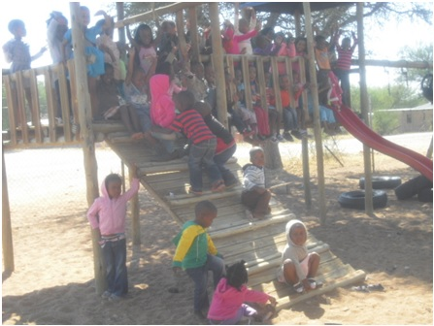

15 June 2013.

- Our developmental plan in March, April and May

Tasks:
- Children’s development at pre-schools
- Assist the pre-schools – focusing on the early childhood development – cognitive skills, coordination of perceptions and movements and social skills.
- Showing alternative methods in the early childhood for the pre-schools
- Preparation of materials for the pre-schools to children’s development
- Monthly and Weekly reports
- Every Saturday we prepare the next weekly report and we send it to the office via email.
- In the end of the month we prepare the monthly report and we hand over it to the Project Leader.
- Pre-school teacher’s training
- We prepare for a Pre-school teacher’s training with the staff’s help.
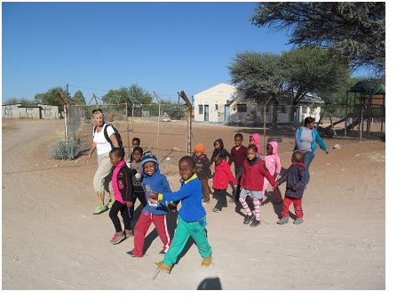
- Our work in the project of Child Aid Ghanzi

  - Official meetings
We took a share in three meetings every month in the office and it was about our work. We have evaluated the previous weeks, and according to the results we made conclusions.
We prepared the teacher’s training:
  - We asked the staff for looking for location of three days teacher’s training
  - We planed the program
  - We prepared the materials

  - Field work
We visited and assisted in these pre-schools:
- In the Mosadi Day Care Center and Pre-School
- In the Morama Pre-school
- In the Fundation Pre-school
- In the Kabakae Baby Care

  - Preparing materials for children
We prepared materials for the development of children’s speech skills. We taught English words for the children in Pre-schools.
We made puppets: chicken, hen, cock, duck, goose, turkey, fox, forest, and fox`s hole.
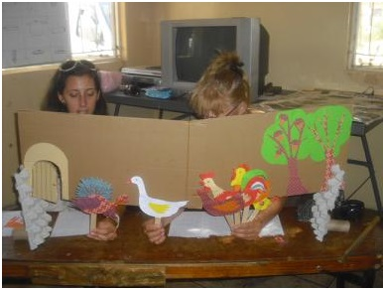
We drew and painted pictures of wild animals. We prepared decorations supporting the speech of the babies.

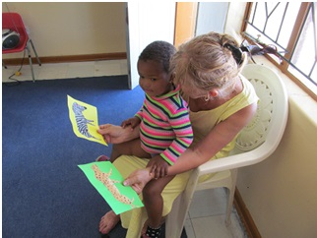

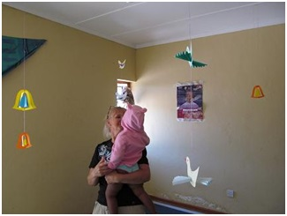

We prepared the following materials for the development of children’s cognitive (logical thinking, counting, categorizing) skills:
  - Puzzles

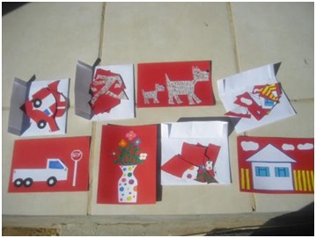

The puzzle is a game where children have to put the peaces of a picture into the correct order next to each other.

  - Dominos

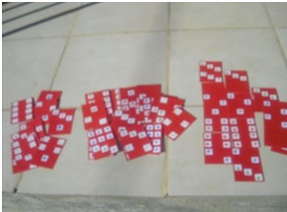 | The children`s dominos are cards, which consist of two parts illustrating different pictures. The objects of our dominos were: one water-melon, two pears, three grapes, four bananas, five plums and six apples. It can be played from two until four children.
The rules of the game: The cards are shuffled face down. The players draw all cards. One player begins by downing (playing the first card) one of their cards. This card starts the line of play. The players alternately extend the line by matching the proper domino with proper field of play with one card at one of its two ends. The game ends if someone manages to put down all of dominos.

  - Board games

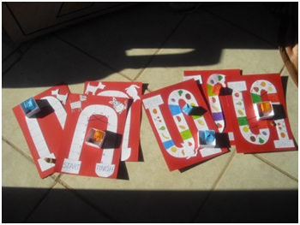

We have done two kinds of the most simplest board games. The boards consist of a winding, linear track made of 15 and 20 mostly white -coloured fields. The remaining two colour fields are special, because from there the players can go ahead or forward or backward. These board games can be played between two and four players.

The rules of the game: Every player has a coloured stone. The first player throws the dice, and he/she steps according to it (with stone from the start). The others continue the throwing and stepping. The player, who reaches the finish first is the winner of the game.
  - Memories

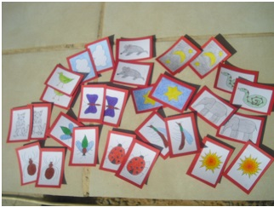
The memory is a card game can be played four players. It consists of 14 pairs of cards. The object is to match more pairs than the opponent. * When cards are turned over, it is important to remember where they are for when the matching card is turned up later in the game.
* At one time one can turn up altogether 2 cards. If they match than the cards remain turned up if not one has to turn them down again.

The rules of the game: Cards are laid out face down/turned down. The first player turns over one card, then another one. If they match, the two cards are removed from the game, and the player gets another turn. If they do not match, the cards will be turned down again.

  - Assisting in the pre-schools
We did six puppet-shows in the Pre-Schools. The title of fable was: Chicken-licken
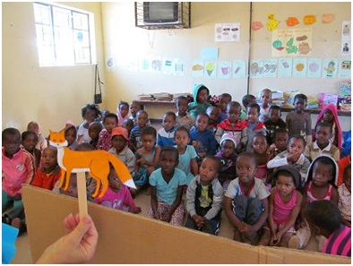

We assisted to play the puzzles in the pre-schools
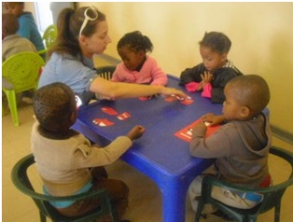 | 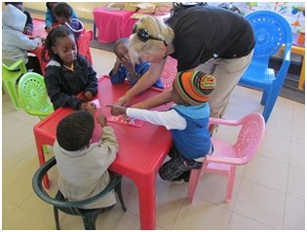
We assisted to play the dominos in the pre-schools:

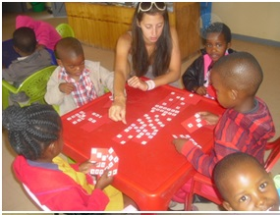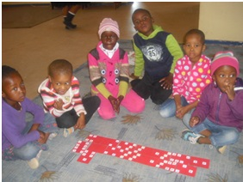

We assisted to play the board games:

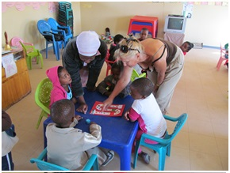

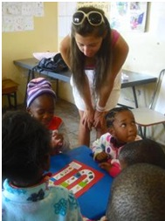

We assisted to play the memory games:
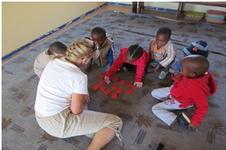
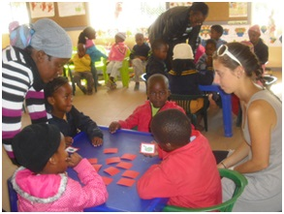

  - Personal development
In the Kabakae Baby Care we provided personal development. We continually observed the kids and planed tasks for them and developed into coordination of perceptions and movements and cognitive skills.

In the Kabakae Day Care Center the teacher begin to teach the babies to sit up, stand and walk earlier, than the caregivers teach them in Europe. The babies reach the developmental milestones of sitting and of walking earlier, than babies in Europe. At the
same time they are not advance in other skills, they lag to roll over and to crawl. The crawling is very important milestone in the development of babies, because it allows them to explore their environment in a new way, acquiring new information about the world and changing how they respond to it.

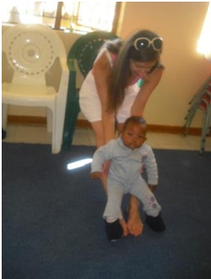

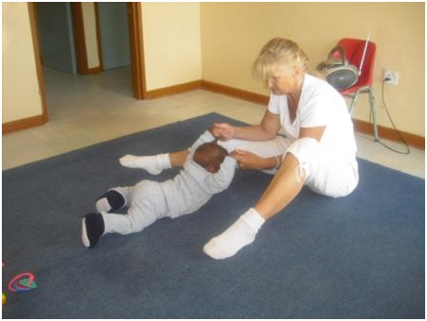
  - Visiting the Library

We organized a visit to the Library for 30 children from the Mosadi Pre-School. The children got to know the library with the help of the Librarian assistant. The kids took the opportunity to play games and they learned a song (McDonald`s farm).

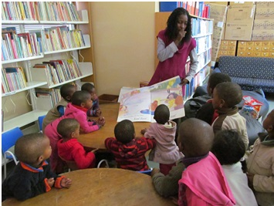

  - New method in Pre-Schools

We noticed that, the children have to wait often in Pre-Schools, because teachers had thought them only playing together. We showed a new method in the Pre-Schools: the children made different tasks or played several games at the same time.
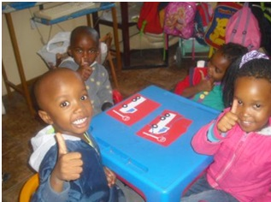 | 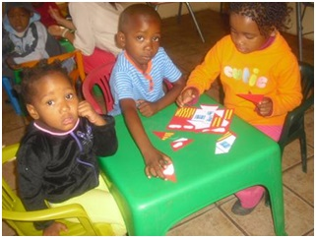
  - Meeting with the Kabakae Community Leaders

The Leaders from Kabakae Community visited our house. They asked us for help to establish a Pre-school in the Kabakae Area. We gave a hand them (our help) of course. Eva has pedagogical work experience in the early childhood. We are going to make an annual plan for the new Pre-School with games and other materials. We just started to set up toys from Europe.
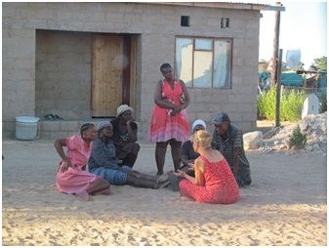

The place of the meeting was our yard.
  - Meeting and sharing experience regarding to work with other volunteers
20th of April we organized a meeting about experience of supporting work in the Ghanzi District with the other volunteers:
Yuko Inoue – Japan International Cooperation Agency – working in Mokubilo village with a social worker in Primary school and any other individuals for Income Generation Program, Community Library Project.
Ryan Schadt – Peace Corps from USA – working at Ghanzi ; clinic worker, volunteer at Primary school, social worker. Project: HIV/AIDS awareness, and English language classes.
Maureen Mersmann - Peace Corps from USA – working at Ghanzi DAC office. Collect, analyze, disseminate statistics and other info regarding HIV/AIDS and other health issues in the district.
Kyla McKea – Canadian volunteer through WUSC. She works with Ghantsi Craft and Kuru.
Toshiyuk Motokana - Japan International Cooperation Agency – he is car mechanic. He teaches about cars in Ghanzi District Council.
- Other experiences in the first half period:
- Relationship between people. They are very friendly, they stop us on the street and they want to speak and get to know us. If we go shopping we often meet someone who ask for one pula or for buying him something to drink.
- The communication with the children in the pre-schools. The communication was very difficult in the beginning the teachers helped us in translation.
- The children could not walk in line outdoor, when we walked to the library. Next month we plan to teach them.
- We got help from the staff. We decided to be educational fighters because we would like to help the children in Botswana. We are just two volunteers from Europe. Without help, we can not reach the goals and do a nice work. That’s why we would like to say “thank you” for the Project Leader and the Country Director. They take care of our accommodation and they raised our food money 1600 pula/month/person from June.
- How the people manage the time in Ghanzi? The workers don’t always care about the clients, it’s very hard agreements with them.
- Our work was not useless for the children. We recommended to the teachers to play with domino and memory games, because they didn`t know those. We were happy to teach new and enjoyable games. It`s nice to see that the teachers often use our games.
- We feed three dogs. Three shy dogs live in our neighbourhood. The people often throw stones at them. We feed them so they feel comfortable in our yard.
- We made a small garden with oriental vegetables.

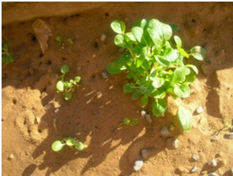

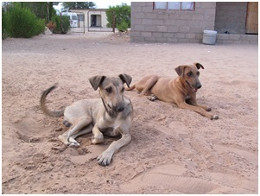

- The statistics

- We participated in work-meetings three times per month in the office.
- We assisted 35 days in March, April and May in three Pre-Schools. (From 1th until 16th of April the pre-schools were closed.)
- More then 150 children participated in early childhood development – cognitive skills, speech and coordination of perceptions and movements in the Pre-schools.
- Four babies were participated in personal development of coordination of perceptions and movements
- We prepared more than 7 puppets (chicken, hen, cock, duck, goose, turkey, fox, forest and fox’s hole) for the kids.
- We managed and organized 6 performances (puppet-shows).
- We made 4 kinds of puzzles and patterns (all in all 24), and we gave them to the pre-schools as a gift.
- We made 2-2 kinds of dominos, board games and memory games (all in all 18), and we gave them to the pre-schools as a gift.
- We managed personal development of babies 12 times.
- We made 9 pictures for kids in order to develop their communication skills.
- We showed a new method of work in the pre-schools.
- We organized and visited with 30 children the library.
- We participated in a meeting with Leaders of Kabakae Community.
- We organized a meeting with 5 volunteers from USA, Canada and Japan.

- Our plan for the next period

In June: We are going to develop the social competence in the Pre-Schools
- We’ll organize a drawing competition in three Pre-Schools.
- We’ll prepare and assist an Olympic games in three Pre-Schools.
In July:
- We’ll make an annual education program for the Pre-Schools
- We’ll make different kind of tests to check the development of the children’s skills
- We’ll prepare lot of useful games for the Pre-Schools
In August:
- Investigation period
- We’ll hand over the project materials and share our experiences.

- Conclusion and Opinion about first half period:
We can conclude that in the first half period at Child Aid Project Ghanzi were very productive, even though we still think that we could have done more.
We can say that now we feel really comfortable to work in the pre-schools with the teachers and with the children. However, on overall we feel like this was a good job, because the pre-school-teachers appreciate our work and the children like our games.
We enjoy the time spending here, because we like our work, the people, our house, the dogs, our garden and the environment.

Ghanzi, 15 June 2013.
Greetings to everyone!
Eva & Lili

